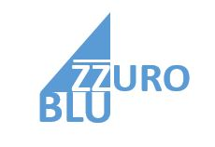
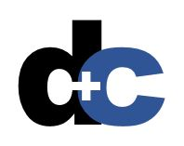
What’s Inside…
A letter from Harry Driver 1
Your Issues and Goals 2
Our Recommendation 3
Our Value Proposition 4
Summary Pricing for Your Solution 5
Attachments 6

Replace with a photo or illustration that represents your customer’s business and your solution.
Create your own descriptive and thematic title.
Affordable, Customized Proposal Services
that Win!
Update your table of contents manually or by using Word’s Table of Contents tool.
Replace with your customer’s name or logo (after receiving permission).

Use your company letterhead and full- or semi-block style for a professional look.

June 21, 2016

Dr. Peter SmithPeter Smith
Azzuro Corporation
321 Main Suite 25
Dallas, TX 75202321 Main Suite 25
Dallas, TX 75202
Use the A-I-D-A letter model for your cover letter. For a short proposal, your cover letter can double as an executive summary.
Attention
Dearr Dr. SmithDear Dr. Smith:
Interest
What is it? What will it do for us? What does it cost? How will it work?
Aren’t that all that your customers really need to know about most business solutions? In your rapid-fire industry, your sales people don’t have time to reinvent the wheel when they need to write proposals: they need an easy-to-follow, repeatable process with easy-to-use, comprehensive models that you can rely on time and again to get the job done.
Desire/Demand
D+C is ready to help Azzuro Corporation rapidly respond to RFPs and proactive proposal opportunities. Our solution has four parts:
- An end-to-end process for managing all proposal opportunities, no matter how simple or complex
- A set of proposal templates that coach content contributors to meet professional standards
- Tools to help proposal or account managers direct the proposal process, including decision-making tools, report formats, project calendars, and more
- Comprehensive training for your proposal teams with just-in-time refreshers before engagements
Plus, with D+C, you get a two-year subscription to our online proposal reference library and template collection. This will go a long way in meeting one of your long-term goals: automating parts of the proposal process.
If you like what you read, please sign the letter of intent at the back of the document and call me so we can finalize the details. If not, please call me so we can adjust our solution to better meet your needs.
- Sincerely,
Action

Dick DiverVan Evans
Sr. Account ManagerAccount Manager
Enclosure: proposal
Your Issues and Goals
Your “current situation” heading should clearly describe what you would address to establish the need for your solution.
Use a callout quote to highlight important content.
“Azzuro Blu Corporation responds to more than 300 RFPs and develops an additional 400 to 500 proactive proposals annually.”
1Azzuro Blu Corporation responds to more than 300 requests for proposals (RFPs) and develops an additional 400 to 500 proactive proposals annually to provide a steady stream of new customers and revenue. But like most companies, you have too few resources that you can dedicate to staffing this critical business development activity. From our discussions with your business development leaders and our experience providing custom proposal development and management solutions for other, similarly sized businesses, we’ve learned about some key issues you face and specific goals you’d like to accomplish.

Issues affecting Azzuro Blu Corporation
Azzuro Blu faces three key issues when creating proposals, both in response to RFPs and when your salespeople uncover needs from existing and potential clients.
• Your current proposal process is not consistent. Some of the people we interviewed describe it as “chaotic” at times. You need a more comprehensive, easy-to-follow approach to organizing and managing reactive and proactive proposal development efforts.
• You know you have a wealth of knowledge about your customers, your competitors, and your solutions that you could reapply to new opportunities, if you could only find a way to capture, store, and reuse them intelligently.
• Your salespeople are overburdened. They not only have to continually make new sales, but they must also service their accounts and track performance against sales plans. Adding proposal work on top of all these duties has caused some of your better salespeople to leave.

These issues are not exclusive to Azzuro Blu, but they are nonetheless painful, and, if solved, would distinguish your company in your market.

Goals you want to accomplish
When we talked recently, you told us that Azzuro Blu has three major goals related to these issues that you hope to reach in this fiscal year:
- Reduce the time and effort you spend in developing reactive and proactive proposals by 20 to 30 percent.
- Increase the professionalism of your proposals and RFP responses, from the content to the illustrations to the packaging and delivery.
- Implement a straightforward proposal process based on recognized standards and the best practices of industry leaders.
Along with these immediate goals, you also have a long-range goal of automating as much of the proactive and reactive processes and outputs as you possibly can. This last area is a particular strength of our organization.

D+C’s solution addresses your key issues and helps Azzuro Blu realize its specific goals—including that difficult and elusive long-term goal. On the following pages, we:
- Describe our solution
- Tell how it works
- Define its key benefits
- Summarize its cost
- Provide a timeline for implementation
- Explain why D+C is your best choice for proposal process development, training, and automation

Our Recommendation
For more information…

…about our proposal support products and services, refer to these documents in the Attachments section:

- Proposal Process Training Guide
- Reactive proposal management templates
- Proactive proposal management templates
- RFP Response Template
- Proactive Proposal Template

After researching your business situation and discussing your options with sales and executive leadership, D+C recommends that Azzuro Blu adopt D+C’s Small Business Proposal Development package to achieve your three main goals for proposal response and development.

What is it?
Our Small Business Proposal Development package delivers everything you need to overhaul your proposal process and leverage the best practices of companies around the world that primarily conduct business through reactive and proactive proposals. The package includes:
- Initial proposal process assessment with documentation leading to a detailed implementation plan
- Twelve customized proposal process templates: including a deal calendar, bid-no/bid decision analysis, kick-off meeting, and key review and production checklists.
- Two reusable proposal templates: one for RFP Responses and the other for proactive proposals.
- A comprehensive proposal process guide
- On-site training for all your proposal personnel
- On-site consulting for up to four proposal opportunities

How does it work?
Our implementation team will work directly with your organization to establish the infrastructure you need to support the end-to-end process. They will assess your current readiness and implement immediate improvements to prepare you for your next opportunity. They will provide you will internal communications models and coach your proposal team to work with key departmental and sales representatives as they adopt the new approach.

Then, our team will train each of your proposal team (proposal managers, writers, editors, and graphics and production specialists) to lead the new process and use the templates and tools. They will then assist your team in training all sales and other contributing organizations to follow the process and use the tools.
Last, we will “ride along” with your proposal team on its first few opportunities—both reactive and proactive—to ensure your success.

What will it do for me?
D+C’s Small Business Proposal Development package will:
- Streamline your proposal development and RFP response process, reducing your time and resource commitment on each new opportunity by an estimated 23%.
- Bring a new level of professionalism by upgrading the look and messaging of each proposal you create.
  - Our reactive templates will reinforce our standard four-part response model, ensuring consistently accurate and complete answers to your customers’ questions.
  - Our proactive template will ensure a common schema for all your unsolicited proposals and build a framework with your customers for improved, ongoing communication.
- Our end-to-end proposal process will identify a repeatable method for capturing and retaining business that is proven to increase your success rates. Our analysts will ensure the right “fit” for your business, market, and competition. Our trainers will instill best practices in your team and guide them through four engagements.

The figure below illustrates the comprehensive process and deliverables we supply with this package.

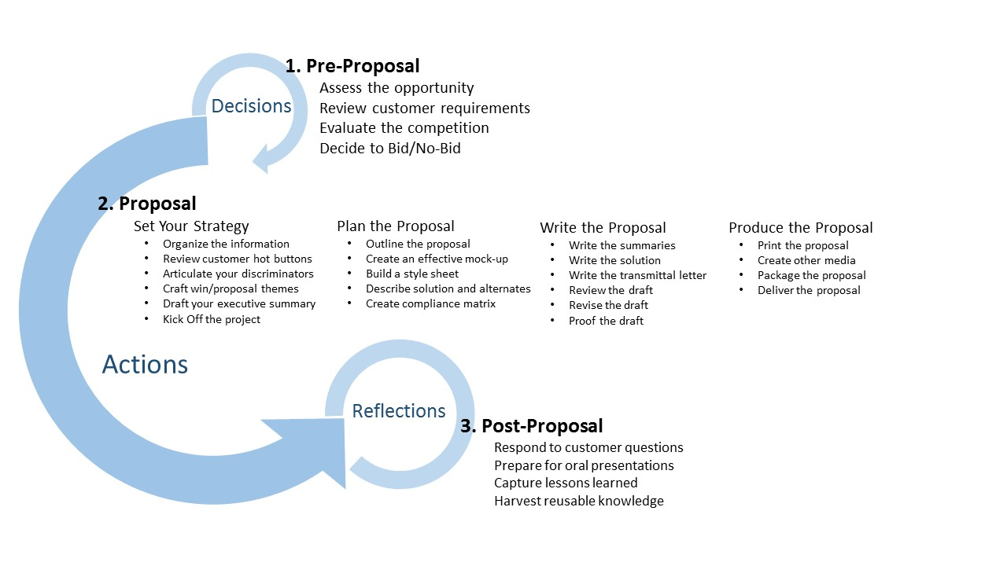
End-to-end Proposal Process. This figure breaks the proposal process into three major stages, with multiple sub-steps to ensure consistent approach to each opportunity.

How much does it cost?
The following table identifies the pricing components for D+C’s comprehensive proposal management solution for Azzuro Blu. For a complete breakdown of line items and prices, see the appendix.
Description | Qty. | Annual Charge | One-Time Charge
Custom Proposal Process (including on-site implementation consultant) | 1 | $0 | $8,000
Custom Proposal Process Templates | 12 | $800 | $3,000
Custom Reactive and Proactive Proposal Templates | 6 | $1,000 | $4,000
Initial Process and Template Train-the Trainers | TBD | $0 | $0
Process and Template Evaluation and Updates | 1 | $500 | $0
Total Costs |  | $2,300 | $15,000

After reviewing your proposal-related sales funnel for the previous six months, we have calculated that your improved processes and deliverables should improve your win rate by 12 – 15 percent. Based on the average value of bids over those months, we estimate the payback period for this investment in your proposal operation to be approximately four months.

How will you implement it?
The following table identifies our proposed timeline for implementing your new proposal process and tools. When you have the process up and operating to your satisfaction, we will re-engage with you to create a second plan for optimizing your process and automating key phases and outputs.

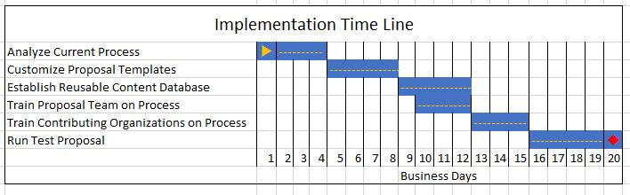

Why You Should Choose D+C
On the preceding pages, we described D+C’s Small Business Proposal Development package, one of our extensive set of integrated proposal development solutions. We have created this plan based on the best practices of hundreds of the world’s best proposal operations, distilling those that apply best to your industry and market. But beyond that, we’ve analyzed your particular strengths and weaknesses to customize our plan to best fit your unique needs. But these are just two reasons why you should choose D+C for this project. Consider as well:
“We have created this plan based on the best practices of hundreds of the world’s best proposal operations, distilling those that apply best to your industry and market.”
• Experience. D+C has more than 10 years in the proposal consulting business. Our founders successfully established and led two of the largest and most successful corporate proposal operations.
• Forward Thinking. D+C has been awarded six U.S. patents for innovations in proposal knowledge management and automation.
• Strong Reputation. D+C has successfully implemented our tools and processes for hundreds of clients like you. They will

Azzuro Blu is ready to take its business development operation to the next level. Let us bring all our resources to bear to meet all your proposal needs.

